Department of computer science



Software Engineering Lab

Project (Sprint 2): **Car Dealership System**

**Group 5**

Waqar Bashir 161104

Usman Nawazish 161122

Hamza Ali 161124

Minhaj Ahmad 161150

Submitted to Mam Aatka Ali

Test cases for login:

Wrong username or password

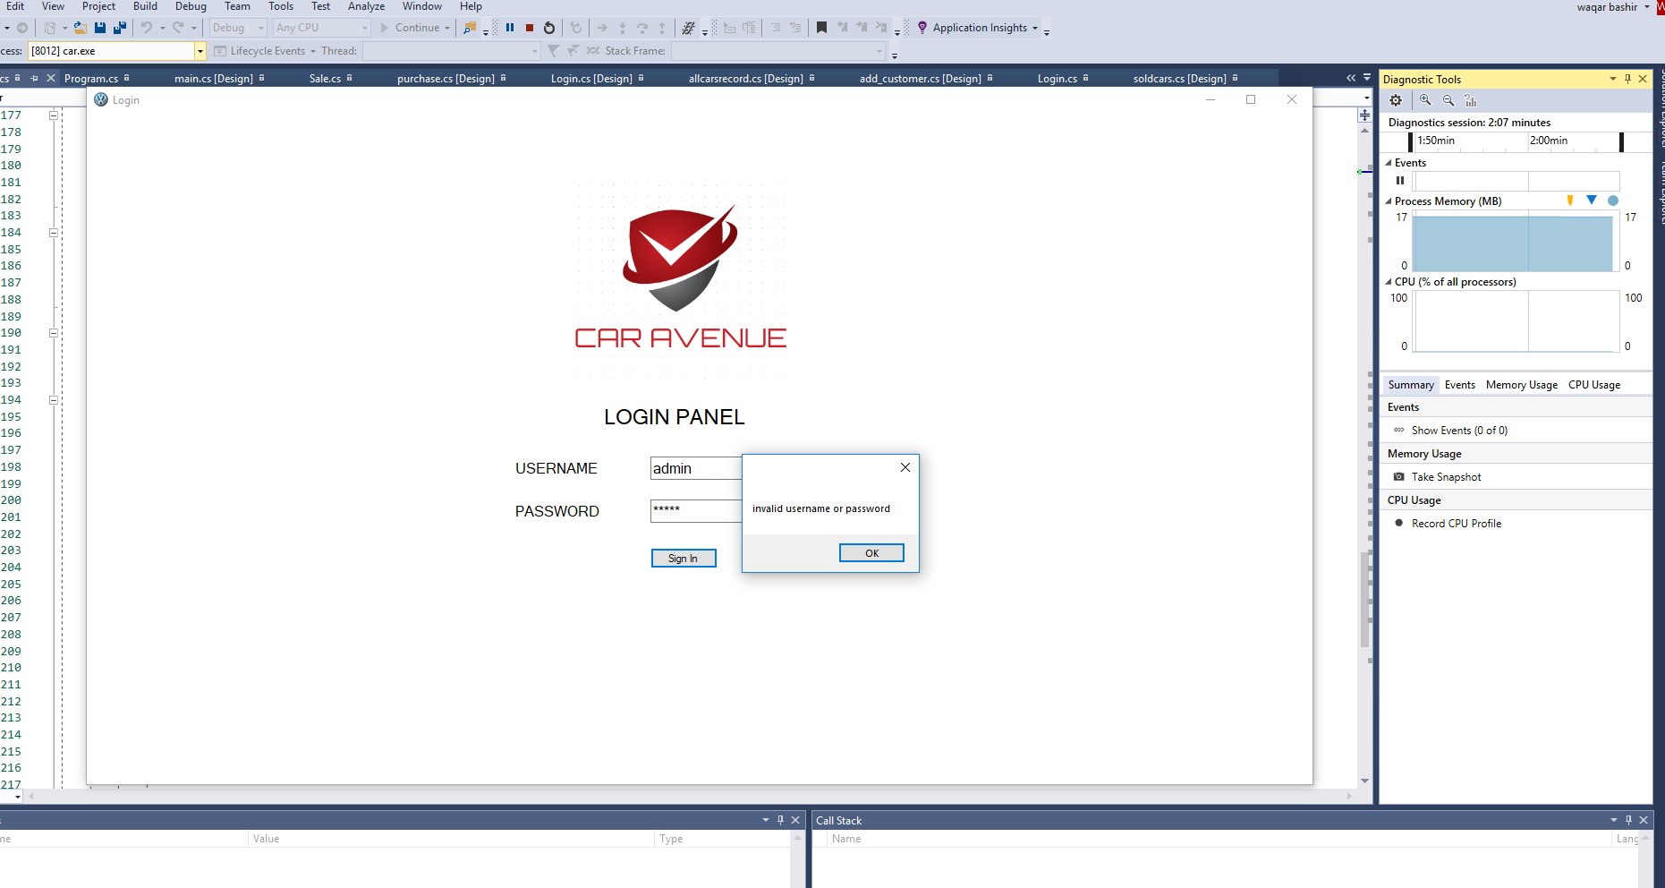

Field left empty:

Without password

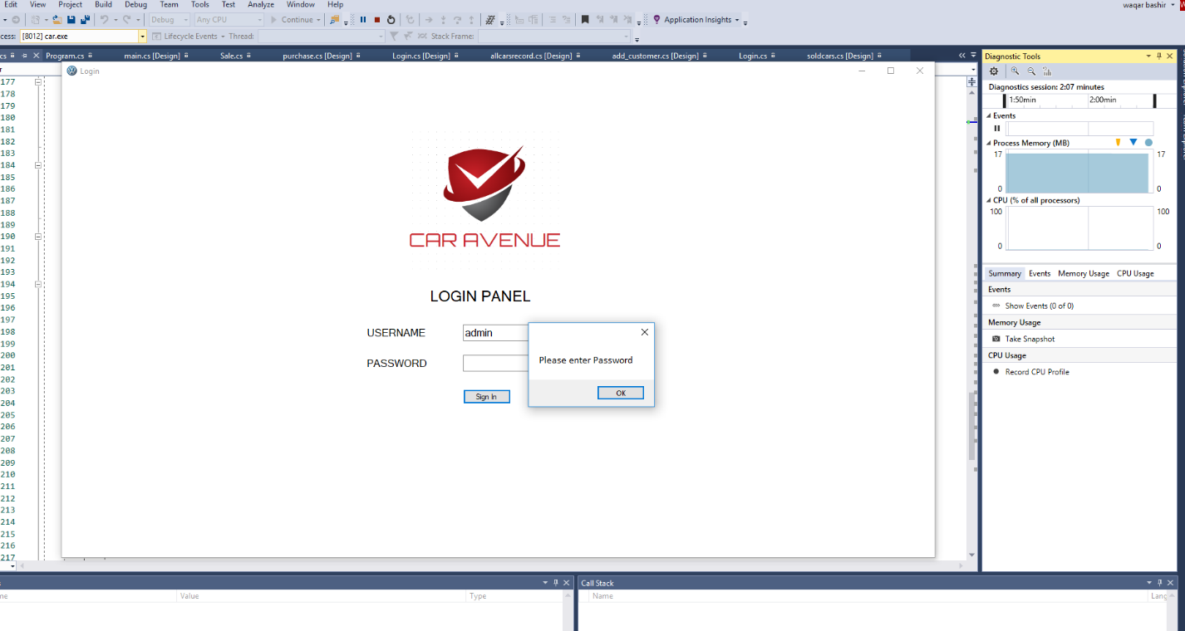

Without username:

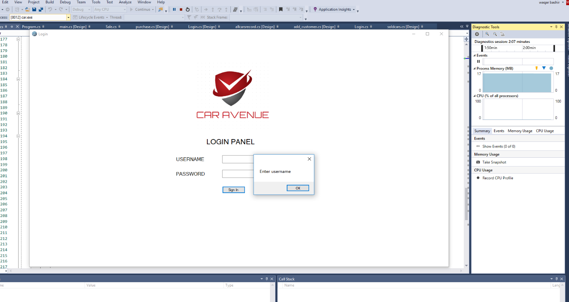

Object oriented design

